Decision tree

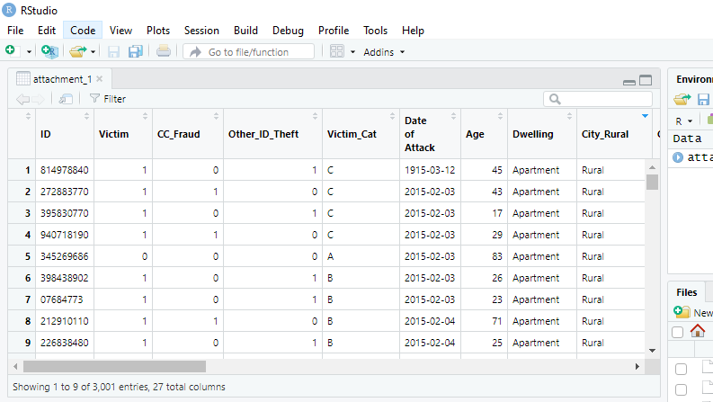
Figure 1: Data displayed in R studio

The crime data displayed in R studio with the rows and the columns. The data has a total of 27 columns with 3,001 entries in total.
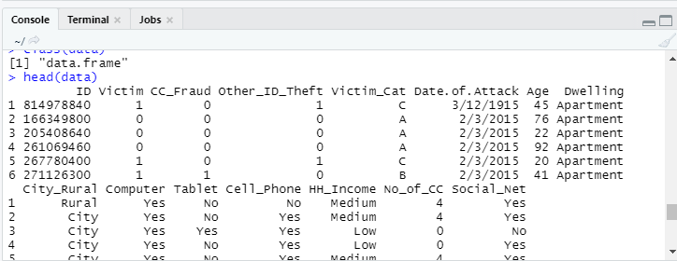

For the data, the independent variable is victim category which is labeled from A,B,C and D. we are going to predict the variable using Age and Tablet (the kind of theft).
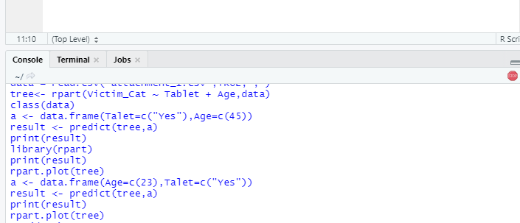
Figure 2: algorithm training

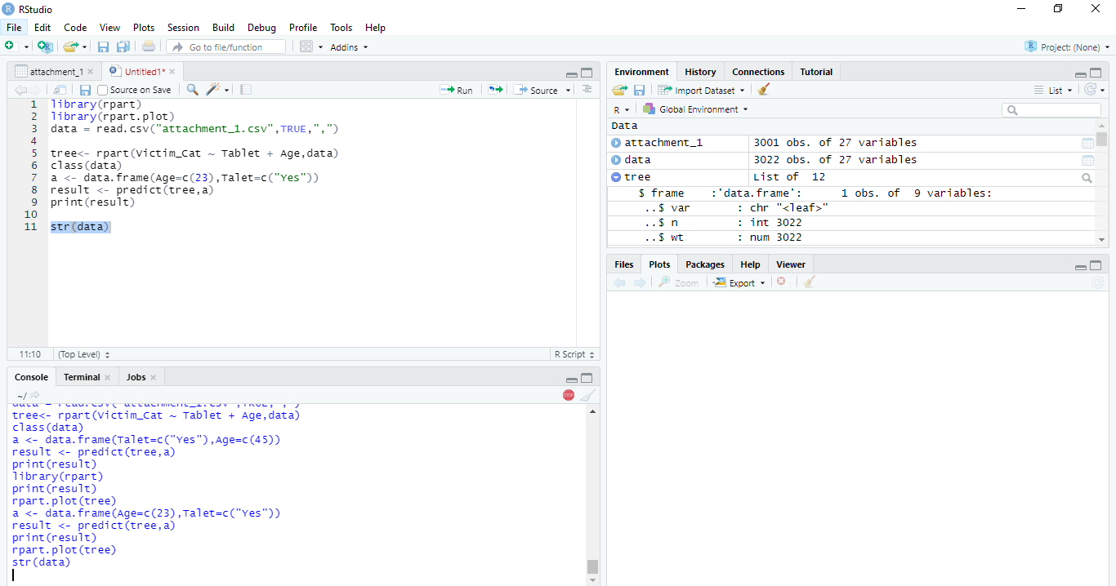
Figure 3: screen plot

Tree diagram
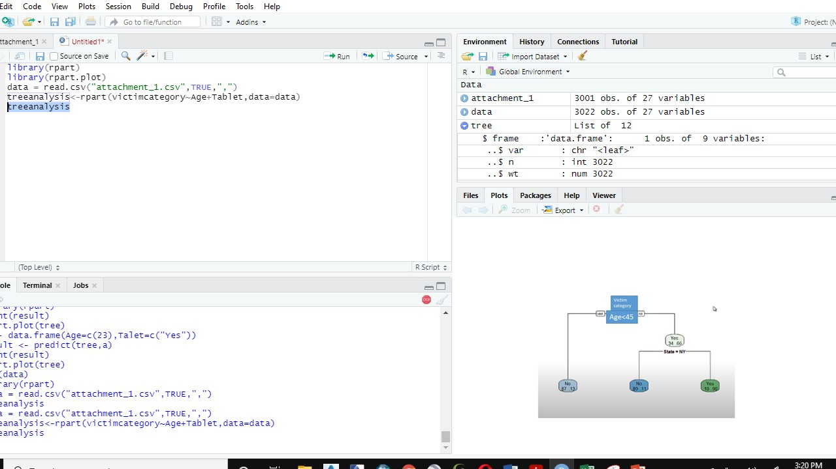
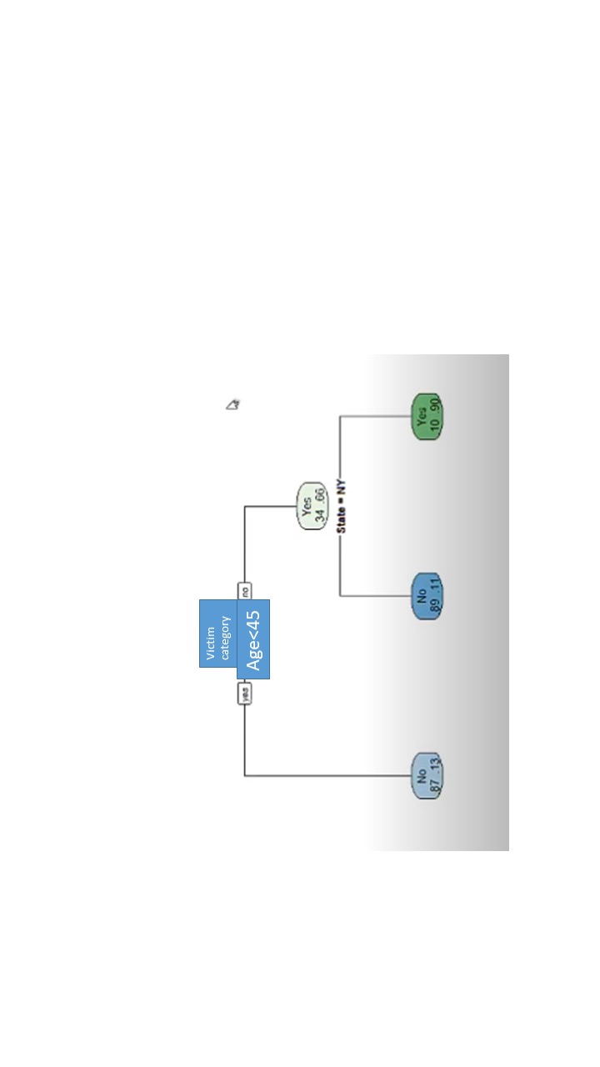
Figure 4: decision tree

Your error statistics Interpretation
The decision tree has taken into consideration a dependent variable which is victim category against two independent variables which are age and crime undertaken. The selected criteria in the algorithm is that the tree to give those people who are age or less or more than 45 years who have a crime related to a tablet. Automatically the algorithm gives an output of NO where those who are less than 45 years do not fall into that criteria. The ages of 45 years and above have two probabilities of someone being involved in a crime related to a table.

